Type here the Authors’ Names: LastName Initials - LastName Initials

Type here the Institution(s) of Authors

Type here the TITle of the paper

This is Heading 1
This is BodyText, all text should be written using this style.
Please follow the standard structure of scientific papers, namely: Abstract, Introduction and aim, Materials and methods, Results and discussion, Conclusion, Acknowledgement, References, …

This is Heading 2

This is Heading 3

This is Heading 4
This is BodyText again.

The next line is in Style Equation. After inserting your equation with the Equation Editor, hit TAB and give it a number that you can refer to later in the paper.
1
Here is how you should insert your Figures in the text:
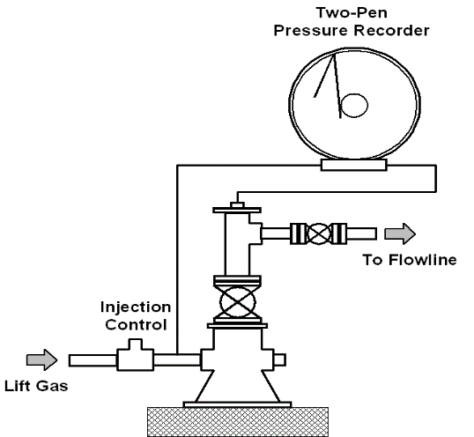
This is the Figure Number
This is the Text of the Caption
Copy or insert the figure in the proper place in your document, format it properly (size, crop, etc.) then select it and give it the style Fig/Table Centered. Then add a new line immediately after the inserted Figure and enter the number of the Figure. The style of CaptionFig is automatically selected for this line. After entering the figure number, hit Enter and type the caption text of the Figure. The style of CaptionFigText is automatically selected for this line.
Now select the Figure, the Figure Number and the Caption Text and insert them in a Frame. The Frame can now be manipulated and placed wherever you desire.

Inserting Tables is done similarly, only the order is changed: first type the table number using the style CaptionTable, then type the caption text using the style CaptTableText, finally insert the Table using the Style Fig/Table Centered. The manipulation with the Frame is identical.

This is the Table Number
This is the Text of the table caption

For Tables, the Frame must not be bordered.

Do Not Forget to include a list of References at the end of the paper. It must be started with the following line using the style RefHeading.

References
- Referenced papers should be given in the style RefItem as shown in the examples below:
- Simmons, W. E.: “Optimizing Continuous Flow Gas Lift Wells.” Part 1. PE August 1972, 46-8.
- Simmons, W. E.: “Optimizing Continuous Flow Gas Lift Wells.” Part 2. PE September 1972, 68-72.

Header/Footers:
No Header is used, Footers should start with the © and should list only the names of the authors as given below.

